**USER GUIDE FOR LEARNINGMANAGER**

Table des matières

Introduction 2

About This Guide 2

System Requirements 2

Installation 2

Getting Started 3

Launching the Application 3

Initial Configuration 3

Registration Process 4

Login Process 5

Main Dashboard 5

Features and Functionality 6

Features in the Book Page 6

Features in the Book Page 9

Features in the Borrow Page 11

Features in the help Page 12

FAQ 12

# 

# Introduction

Welcome to LearningManager, a powerful desktop application designed to help librarians efficiently manage their libraries. This user-friendly application is built using modern technologies including Java, JavaFX, and SQLite to provide a seamless experience across all platforms.

## About This Guide

This user guide provides comprehensive instructions on installing, configuring, and using Learning Manager Whether you're a first-time user or looking for specific functionality, this document will help you get the most out of the application.

## System Requirements

* Operating System: Windows 10/11, macOS 10.14+, or Linux
* Java Runtime Environment (JRE) 11 or higher
* Minimum 4GB RAM (8GB recommended)
* 100MB free disk space
* Screen resolution of 1280x720 or higher

## Installation

**Advanced Installation (From Source)**

For developers or advanced users who want to build from source:

1. Ensure you have the following prerequisites installed:
   * Java Development Kit (JDK) 11 or higher
   * Maven 3.6+
   * Git (optional, for cloning the repository)
2. Clone or download the source code:

git clone https://github.com/HonluePetnou/LearningManager.git

1. Navigate to the project directory:

cd LearningManager

1. Build the application using Maven:

mvn clean package

1. Run the application: using the class App in the location

LearningManager\src\main\java\com\example\librarymanager\App.java

**First-Time Setup**

Upon first launch, the application will:

1. Create a local SQLite database
2. Prompt you to create an administrator account

# Getting Started

## Launching the Application

* Double-click the launcher in your code editor

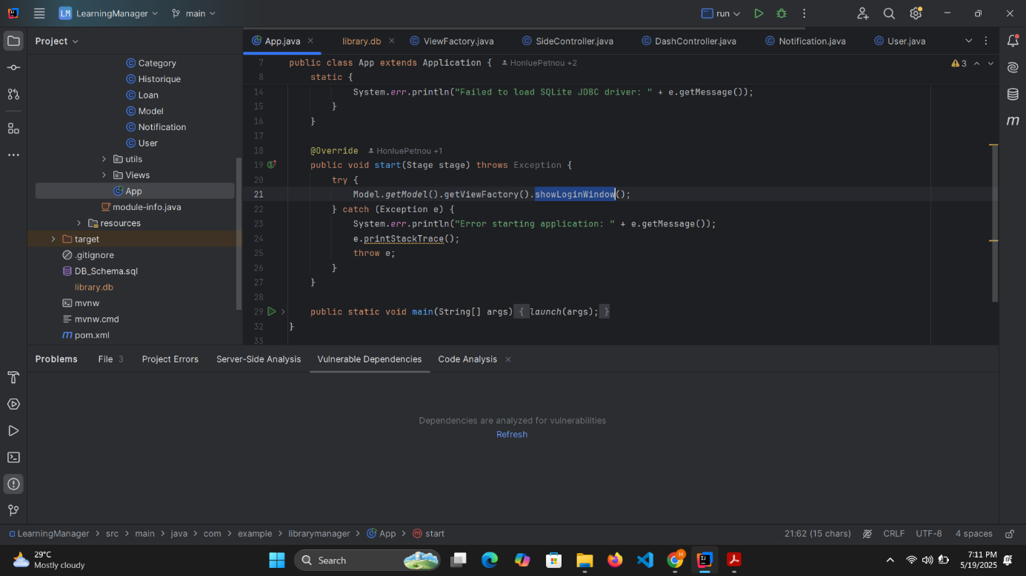

## Initial Configuration

1. On first launch, you'll be greeted with a welcome Login screen
2. Follow the on-screen instructions to:
   * Create your profile using the Sign up link

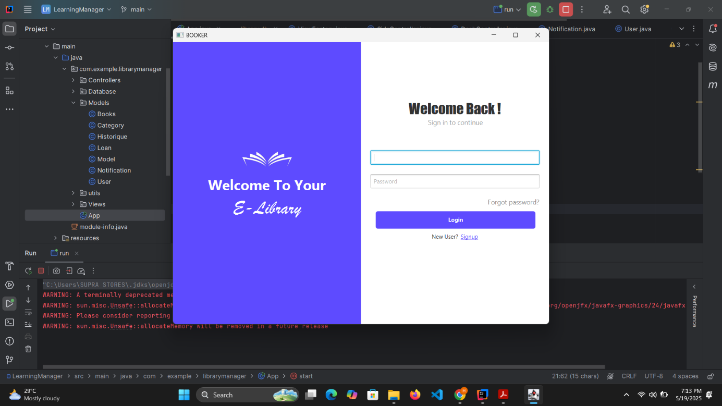

### Registration Process

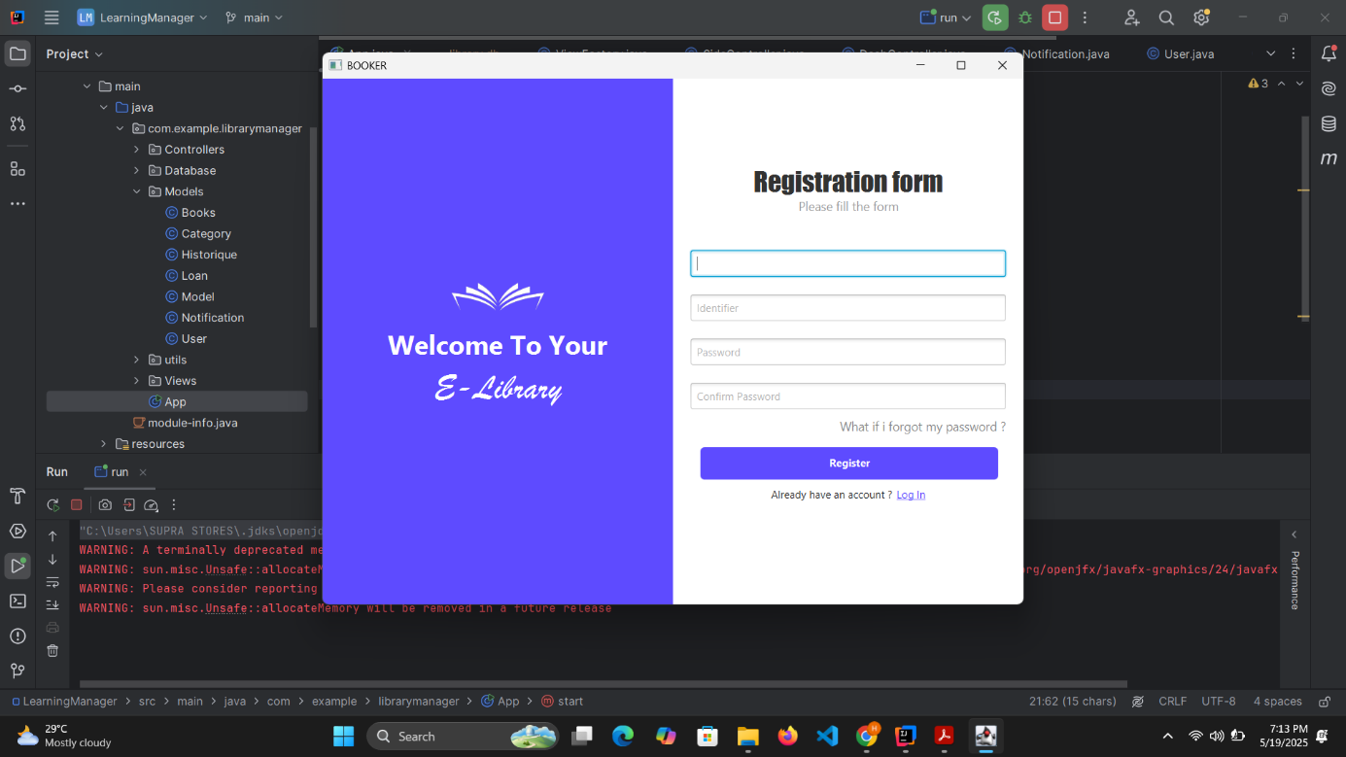

1. Fill all the fields
2. Submit it using the Register button
3. Then Login

### Login Process



1. Enter your username and password in the login screen
2. Click "Login" to validate
3. The get to the main view

## Main Dashboard

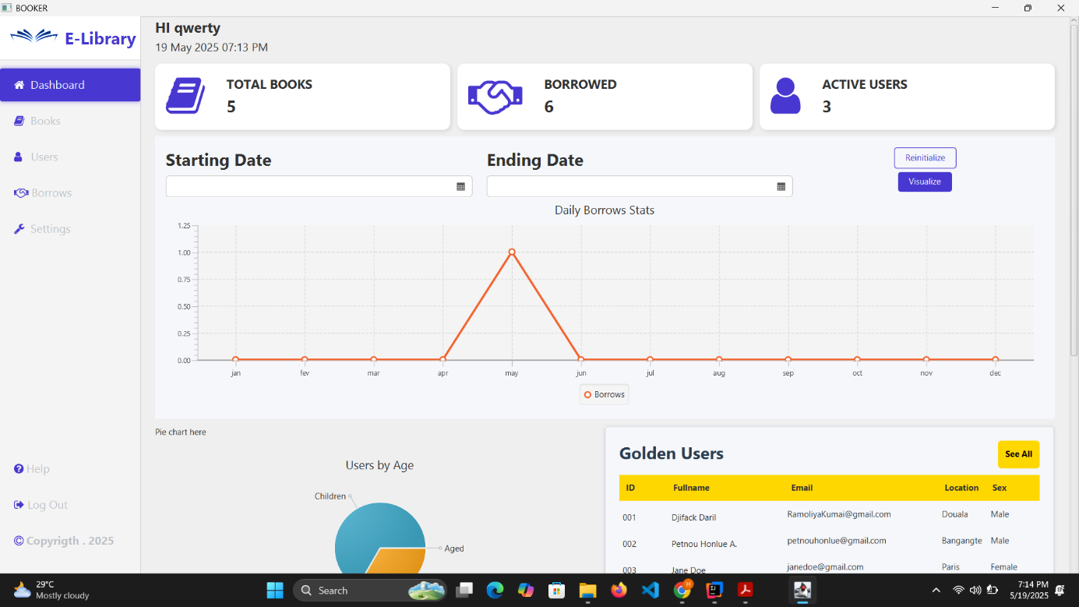

The main dashboard is your central hub for accessing all features:

* **Navigation Menu**: Located on the left side, provides access to all major sections
* **Statistics :**  There’s a line chart and a pie chart for getting actualized data from the library
* **Content Area**: containing the most famous users and at the bottom the most loaned books

**Key UI Elements**

* **Cards**: Visual elements displaying summary information
* **Tables**: Organized data in rows and columns with sorting capabilities
* **Charts**: displaying data progression

# Features and Functionality

## Features in the Book Page

The Book Page provides comprehensive management features for handling book entries. Users can navigate to this section from the main menu to access these features:

1. **Adding New Books** :

* Navigate to the Books Management section
* Fill in the required fields: Title, Author, ISBN, Year, etc.
* Click the "Add Book" button to create a new book entry
* An alert will display to confirm the addition was successful

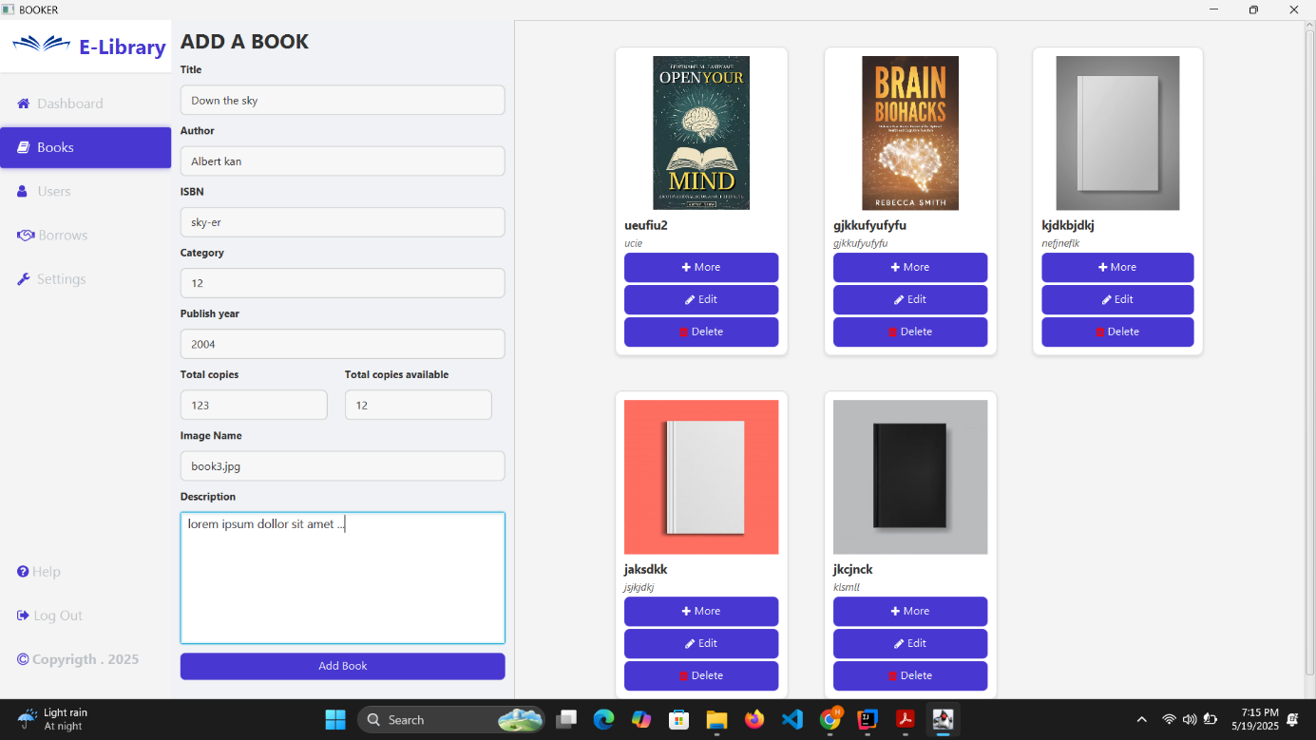

1. **Viewing and Managing Books** The existing books are displayed in a table view where users can View book and their details.

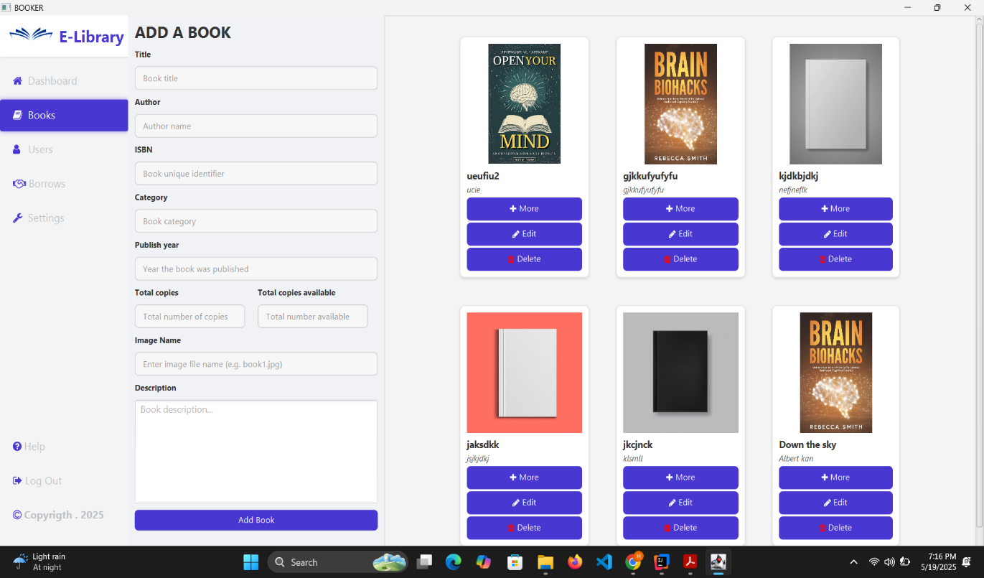

1. **Editing and Deleting Books** :

* Editing: Click the Edit icon in the call-to-action area at the bottom of a book card to modify its details
* Deleting: Click the Delete icon to remove a book from the system

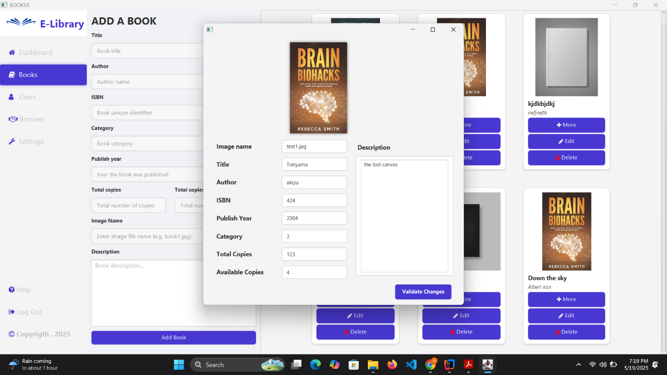

Editing a book using his edit call to action

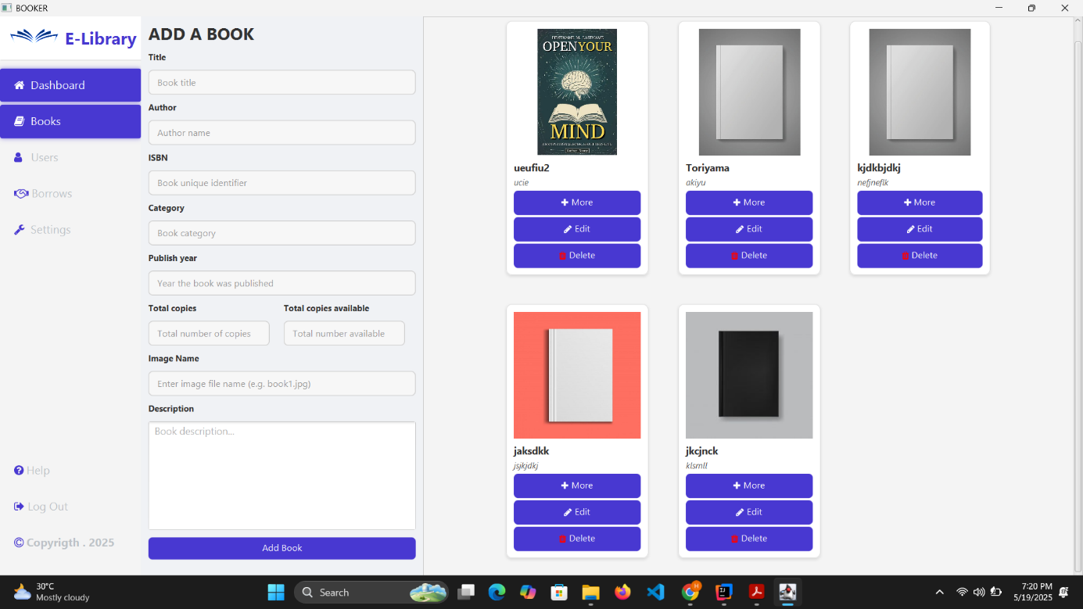

Deleting a book using his delete call to action

1. **Make a loan** :

* Click on the "More" button on a book card to access book details
* Click the "Borrow" button to initiate a loan
* Fill in the loan form with required information
* Submit the form to complete the loan process

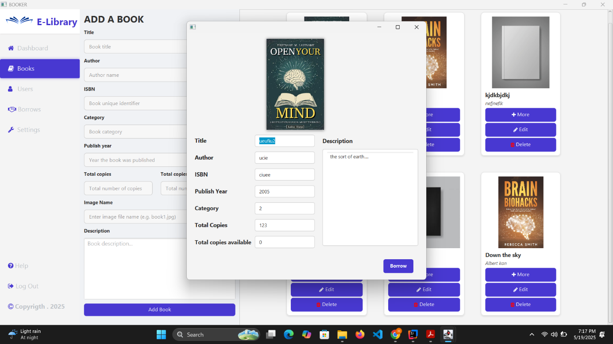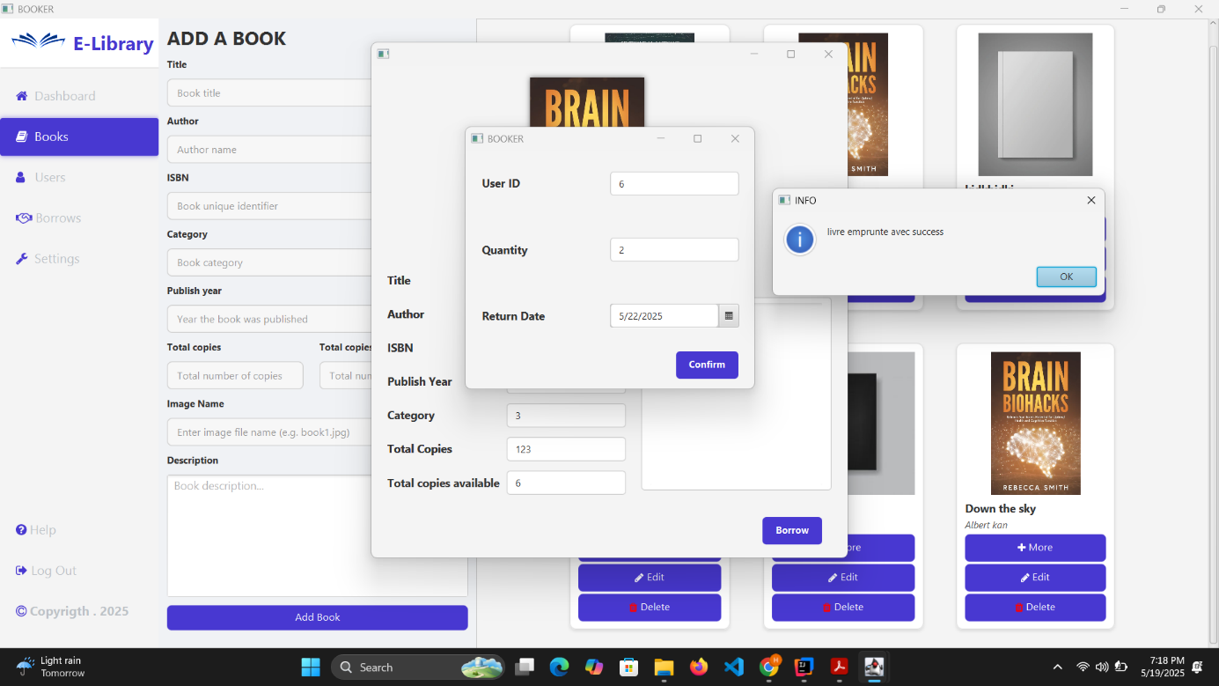

## Features in the Book Page

The User Management section allows administrators to manage library patrons:

1. **Adding New Users :**

* Navigate to the User Management section
* Click the "Add User" button
* Fill in required fields: First and Last Name, Age, Number, Date, and Sex

Submit the form to create the new user

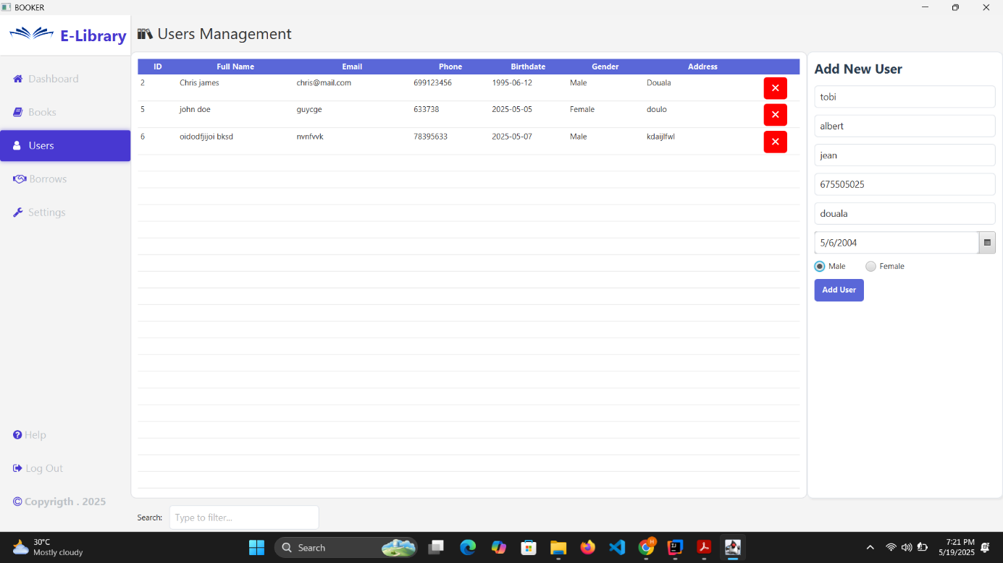

1. **Viewing and Managing Users ,** The existing users are displayed in a table view where administrators can:
   * Sort entries by clicking on column headers
   * Filter users using the search bar
   * View user details

**( Like in the image up )**

1. **Deleting Users :** Admin delete a user using the "Delete" icon .

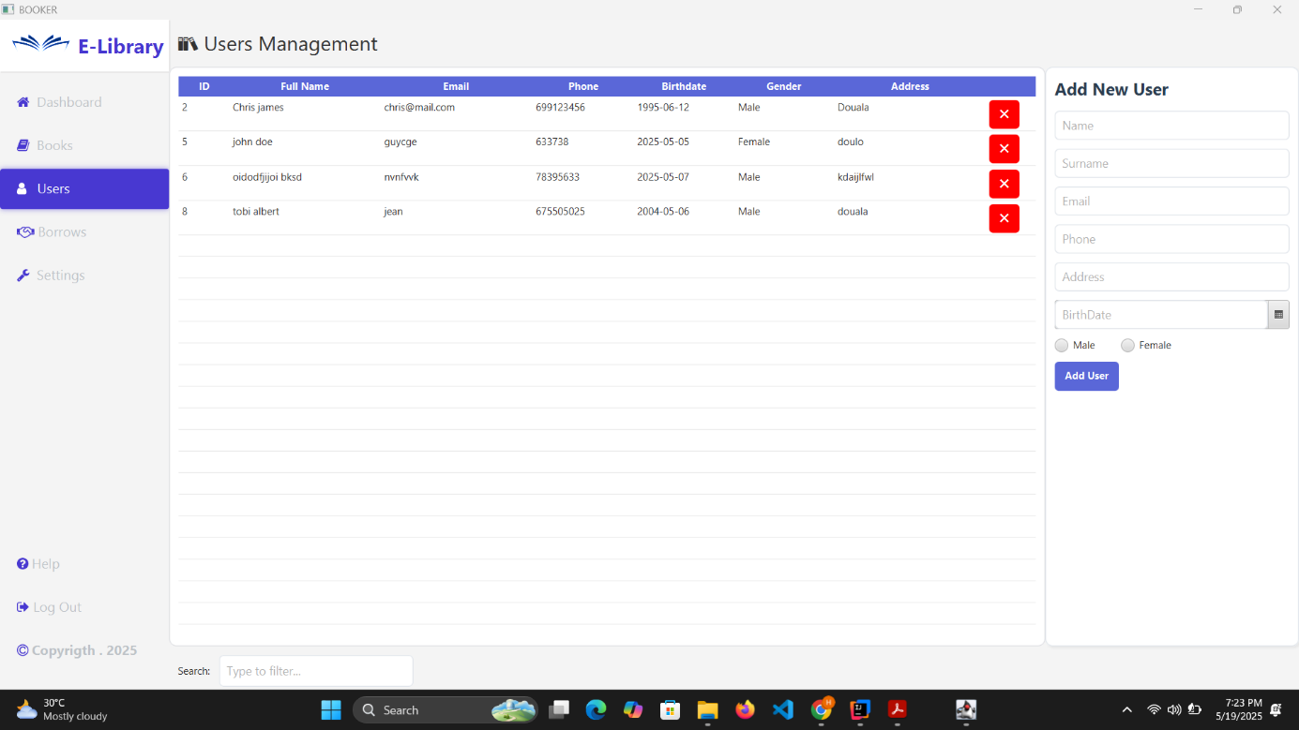

## 

## Features in the Borrow Page

The Borrow Management section allows users to track and manage book loans:

1. Viewing Loans : View loan details including borrower, book title, borrow date, and return date

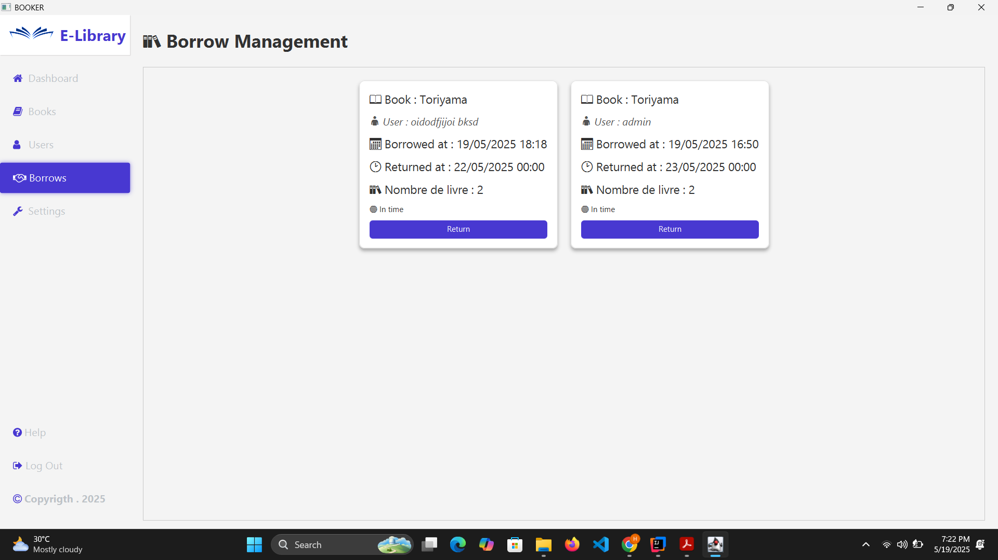

1. Managing Returns : Users can process book returns through this interface:
   * Locate the loan in the table
   * Click the Return button to register the return
   * Confirm the return action when prompted

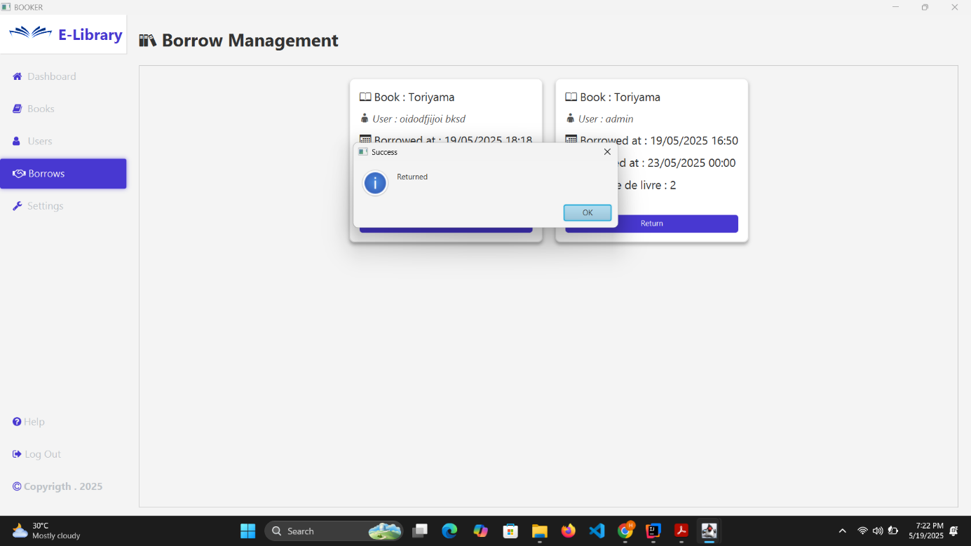

## Features in the help Page

he Help section provides assistance and guidance for using the LearningManager application:

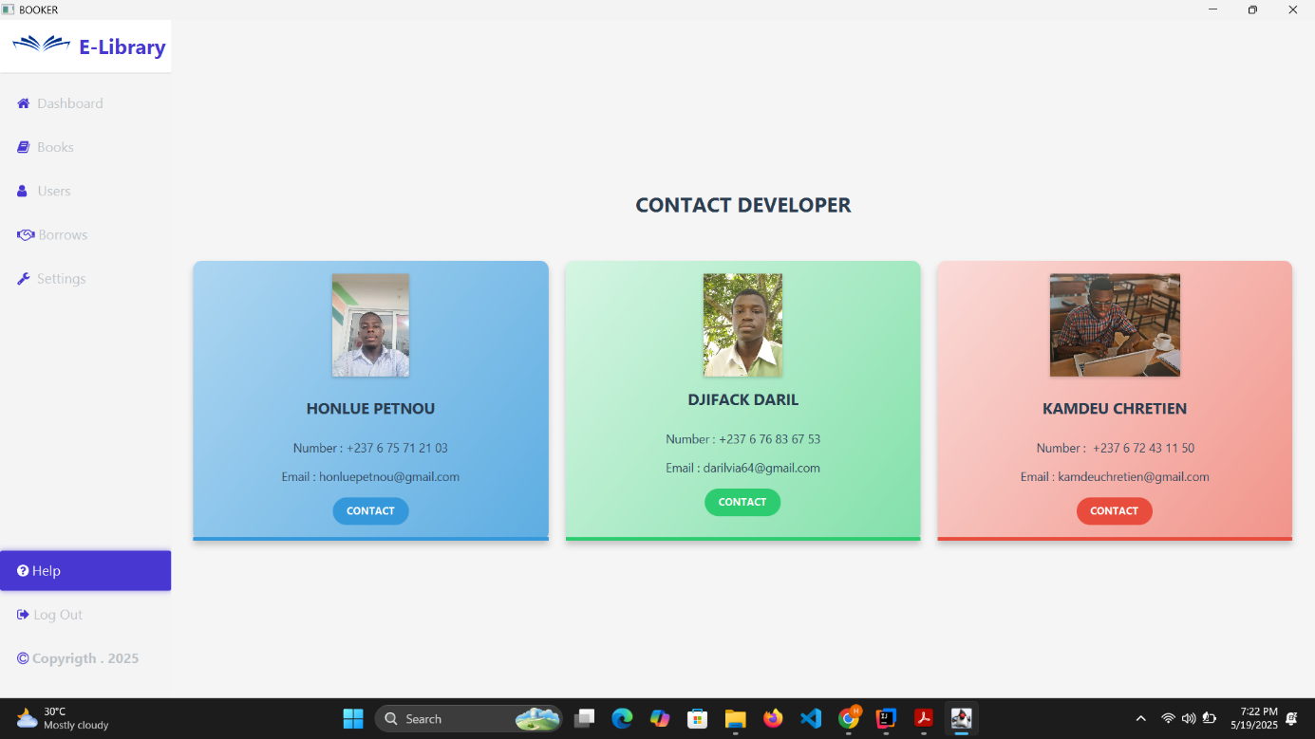

# FAQ

**Q: Can multiple users work with the system simultaneously?**  
A: The current version supports single-Admin operation. Multi-user functionality may be added in future releases.

**Q: How do I reset my password?**  
A: Contact your system administrator to reset your password.

**Q: Can I export library data to other formats?**  
A: Currently, the system doesn't support direct exports. This feature is planned for future updates.

**Q: Is there a limit to how many books a user can borrow?**  
A: This depends on your library's policy settings, which can be configured by administrators